A free way to raise funds for our church!

Dear Whiting Community Church families,
We are part of a free program that can help raise substantial funds for our church. Over 200 area businesses including Festival Foods, Pizza Hut, Panda Express, Moto Mart, Express, Applebee’s, Solea Mexican Grill, Papa Murphy’s, HuHot, Copper Rock, Culver’s of Neenah and Gordman’s, just to name a few, currently participate in this program.

You would register your VISA credit card or debit card, and every time you make a “CREDIT” purchase with the card(s) that are registered, a portion of the purchase will be applied to this program.

Credit Card Security through Linkable networks, link/video available on website.
PCI Level 1 Complaint (Payment Card Industry), TRUSTe Certified Privacy, meaning data is not shared.

Register now to help raise funds for our church.

It is free to register:
- Visit www.ucmission.com/join and click “Join Now”.
- Choose to support “Whiting Community Baptist Church” when registering.
- Our church will receive 0.5-10% cash back on the purchases you make.

Thanks in advance for your support!
Full List of Businesses is available on the ucmission.com website

Kim Rose
Congregational Finance Coordinator

Here are some of the businesses offering cash back:
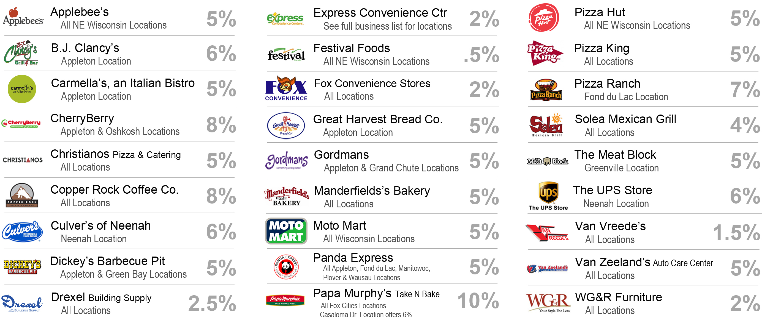
See the full business list at www.ucmission.com

